M-CSC005U1 · Computational Mathematics and Data Analytics · Level 4
Mathematical and Data Analytics
Group Project

Group Project (Coursework) — Assessment 1 (60% of module)

Phone Company SQL Database

Group Members | 1. David Anyanwu - 25018843
Course / Programme | Computer Science
Module | Computational Mathematics and Data Analytics
Module Code | M-CSC005U1
Module Leader | Kenneth Nweke
Assessment Title | Mathematical and Data Analytics Group Project
Project Topic | Voltura Phones SQL Databse
Intended LOs | Construct and evaluate mathematical and statistical models to represent and  interpret real-world computing scenarios, Communicate analytical results effectively and ethically through structured  technical reports, visual representations, and collaborative projects.
Word Count | 2938 Word

Academic Integrity Declaration

We confirm this submission is our own group work. All code is original or properly attributed.
AI tools used for debugging only — documented in the README. All sources are properly acknowledged.

Table of Contents
Table of Contents 3
List of Figures 5
List of Tables 6
1. Executive Summary 7
2. Problem Definition and Context 8
2.1 Problem Statement 8
2.2 Project Objectives 8
2.3 Project Topic Selected 8
2.4 Dataset and Resources 8
3. Mathematical and Statistical Methodology 9
3.1 Mathematical Framework 9
3.2 Model Construction 9
3.3 Statistical or Algorithmic Approach 9
3.4 Assumptions and Constraints 9
4. Implementation Approach 11
4.1 Tools and Technologies 11
4.2 Data Preparation and Cleaning 11
4.3 Code Structure and Design 11
5. Results and Analysis 12
5.1 Descriptive Statistics 12
5.2 Visual Outputs 12
5.3 Model Results and Interpretation 13
5.4 Comparison and Evaluation 13
6. Ethical Considerations 14
6.1 Data Ethics and Privacy 14
6.2 AI Tool Use 14
6.3 Broader Ethical Implications 14
7. Conclusions and Recommendations 15
7.1 Summary of Findings 15
7.2 Evaluation Against Objectives 15
7.3 Limitations 15
7.4 Recommendations and Future Work 15
8. References 17
Appendix A — Group Contribution Summary 18
Appendix B — Individual Reflective Statement 19
B.1 Reflective Statement — [David Anyanwu, 25016843] 19

List of Figures
Figure 1 — Scatter plot diagram ................................ p. [8]
Figure 2 — Relationship between tables .............................................. p. [11]
Figure 3 — Creating Table............................ p. [11]
Figure 4 — Inserting into Tables ........................... p. [12]
Figure 5 — Altering tables ........................... p. [12]
Figure 6 — Distribution of Order status ........................... p. [14]
Figure 7 — Order value over time ........................... p. [15]
Figure 8 — Customer spending pattern ........................... p. [16]
Figure 9 — Distribution of Order amount ........................... p. [17]

List of Tables
Table 1 — Descriptive Statistics for Key Dataset Variables .................................. p. [11]
Table 2 — Group Member Contribution Summary . .............................................. p. [21]

1. Executive Summary
This report presents the design and implementation of a relational database system for a fictional phone company(Voltura Phones) similar to Apple. The aim of the project is to efficiently manage customer data, phone products, and sales transactions using SQL. A structured relational model was developed with multiple linked tables, including Customers, Phones, Orders, and Payments. SQL queries were used to retrieve and analyse data, such as total revenue and customer purchasing behaviour which helped us to find out which devices or payment plans were preferred by the customers. The results demonstrate that the database improves data organisation, scalability, and efficiency compared to manual systems. The project highlights the importance of database systems in real-world business operations and provides a foundation for future data-driven decision-making.

2. Problem Definition and Context
Voltura phones currently manages customer information, sales transactions using manual data handling methods. This leads to issues such as duplicated records, inconsistent data , and difficulty analyzing and processing the data. This creates problem in business operations as well. There is a need for a well-designed relational database system which can organise and analyze the data, which helps in business decision making , business operations.

2.1 Problem Statement
Voltura phones lacks a structured system for managing its core business data,including customer information, phone products,orders and payment records. The company is dependent on manual processes which results in inconsistent data, duplicated entries and other mistakes in the data. These issues creates disturbances in business operations. For this, a relational database system is required to manage data, upgrade business processes and enable error identification and its analysis.

2.2 Project Objectives
- Design a relational database.
- Program the database using SQL.
- Store customer, product, and transaction data
- Perform queries to analyse sales and trends
- Create visual representations of the results

2.3 Project Topic Selected
A simulated database was created representing a fictional phone company(Voltura Phones). It includes customer information, phone models, prices, and order transactions. This approach allows full control over the data structure and ensures consistency for analysis

2.4 Database and Resources
The Voltura Phones database was designed and implemented using MySQL through phpMyAdmin. The database consists of six interconnected tables: Customers, Phones, Inventory, Orders, Order_Info and Payment. Primary and foreign key relationships were used to ensure data integrity and eliminate redundancy through normalisation.

The data set is synthetic and was created specifically for this project to simulate the operations of a modern smartphone retailer. It contains customer information, product details, inventory records, order transactions and payment data. The database structure enables efficient querying, reporting and analysis of business performance indicators such as sales trends, customer spending behaviour and product popularity.

3. Mathematical approach

3.1 Mathematical Framework
The Voltura Phones database is based on relational algebra and descriptive statistics. Relational algebra provides the foundation for SQL operations such as selection, projection, joins and aggregation. Statistical measures including mean, standard deviation and total revenue were used to analyse order data and identify customer purchasing patterns.
The average order value was calculated using:
Mean = Σx / n
where Σx is the total of all order amounts and n is the number of orders. These calculations helped evaluate sales performance and customer spending behaviour.

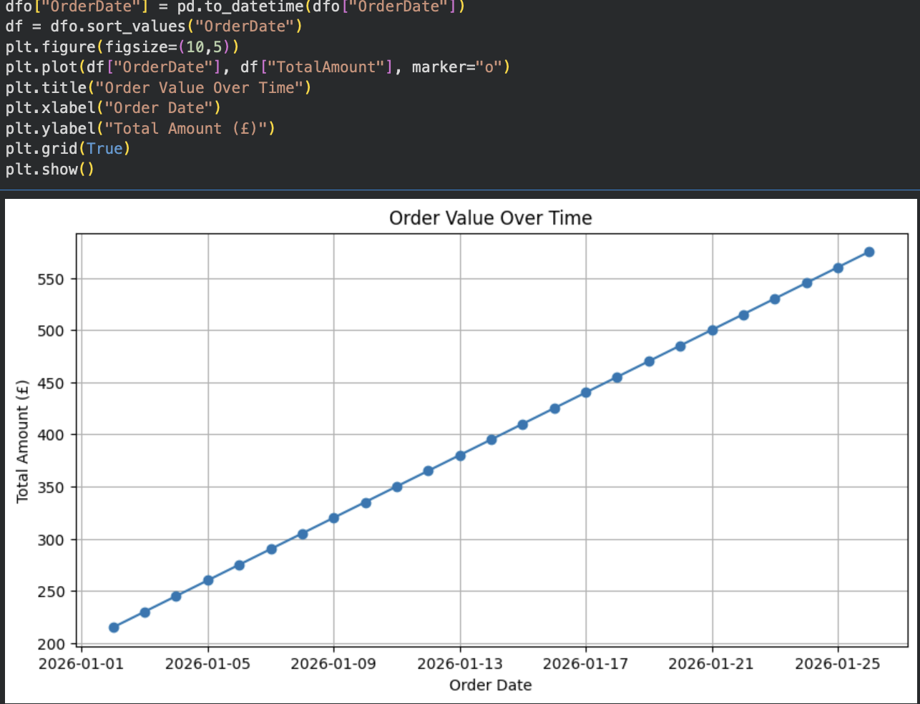
Figure 1 — Scatter Plot diagram

3.2 Model Construction
Based on the order table, there is a perfectly linear relationship between the order date and the total amount. The total amount increases by exactly 15pounds for each subsequent day.
We can represent this relationship using a linear model:
TotalAmount=m x t+c
Where:
- m is the slope (the daily increase in amount), which is 15.
- t is the time elapsed in days.
- c is the intercept (the baseline amount).
Depending on how you choose to define the baseline date (t=0), the mathematical model can be written in the following equivalent ways:

Option 1: In terms of days since January 1, 2026
If t represents the number of days since January 1, 2026 (such that January 2, 2026 is t=1):
Total Amount=15t+200

Option 2: In terms of days since the first order date (January 2, 2026)
If t represents the number of days elapsed since the start of the records on January 2, 2026 (such that January 2, 2026 is t=0):
Total Amount = 15t + 215

Verification:
- On 2026-01-02 (Option 1: t = 1, Option 2: t = 0): Total Amount = 15(1) + 200 =1 5(0) + 215 = 215
- On 2026-01-03 (Option 1: t = 2, Option 2: t = 1): Total Amount = 15(2) + 200 = 15(1) + 215 = 230
- On 2026-01-26 (Option 1: t = 25, Option 2: t = 24): Total Amount = 15(25)+200 =15(24) + 215 = 575

3.3 Statistical or Algorithmic Approach
The project used descriptive statistical analysis and SQL aggregation techniques to examine customer purchasing behaviour and sales performance. SQL functions such as COUNT(), SUM(), AVG(), MAX() and MIN() were applied to calculate key business metrics from the Orders table.

Data was grouped using GROUP BY clauses to identify customer spending patterns and order status distributions. The results were then exported to CSV format and analysed in Python, where visualisations such as pie charts, line graphs, bar charts and histograms were generated to identify trends and patterns within the data.

These methods transformed raw transactional data into meaningful business information that supports decision-making and performance evaluation.

3.4 Assumptions and Constraints
Several assumptions were made during the development of the Voltura Phones database:

• Each customer is assigned a unique CustomerID.

• Each order belongs to one customer only.

• Product prices remain constant during the analysis period.

• All payment and order records are accurate and complete.

• Foreign key relationships correctly link related tables.

The main limitation of the project is that the dataset is simulated and therefore may not fully represent real-world customer behaviour. In addition, the relatively small dataset limits the depth of statistical analysis that can be performed. Despite these constraints, the database provides a realistic representation of a phone retail business and demonstrates effective database design and analytical techniques.

4. Implementation Approach

4.1 Tools and Technologies
The Voltura Phones database was implemented using MySQL and managed through phpMyAdmin. MySQL was chosen because it is a reliable relational database management system that supports efficient data storage, querying and data integrity. phpMyAdmin provided a user-friendly interface for creating tables, managing relationships and executing SQL queries.
Python was used to analyse exported CSV data and generate visualisations. The Pandas library was used for data manipulation and statistical analysis, while Matplotlib was used to create charts and graphs that supported data interpretation.
The development environment consisted of:
• MySQL – database management and querying.
• phpMyAdmin – database administration.
• Python – data analysis and visualisation.
• Pandas – data processing.
• Matplotlib – graphical visualisation.
4.2 Data Preparation and Cleaning
Before analysis, the Voltura Phones database underwent several data preparation procedures to ensure data quality and consistency.
- Data types were standardised using INT, DECIMAL, VARCHAR and DATE fields.
- Incomplete or invalid records were identified and removed.
- Foreign key relationships were validated to ensure referential integrity.
- Duplicate records were prevented through primary key constraints.
- Text fields were formatted consistently to improve data quality.
These cleaning procedures ensured that the dataset was accurate, consistent and suitable for analysis.

4.3 Code Structure and Design

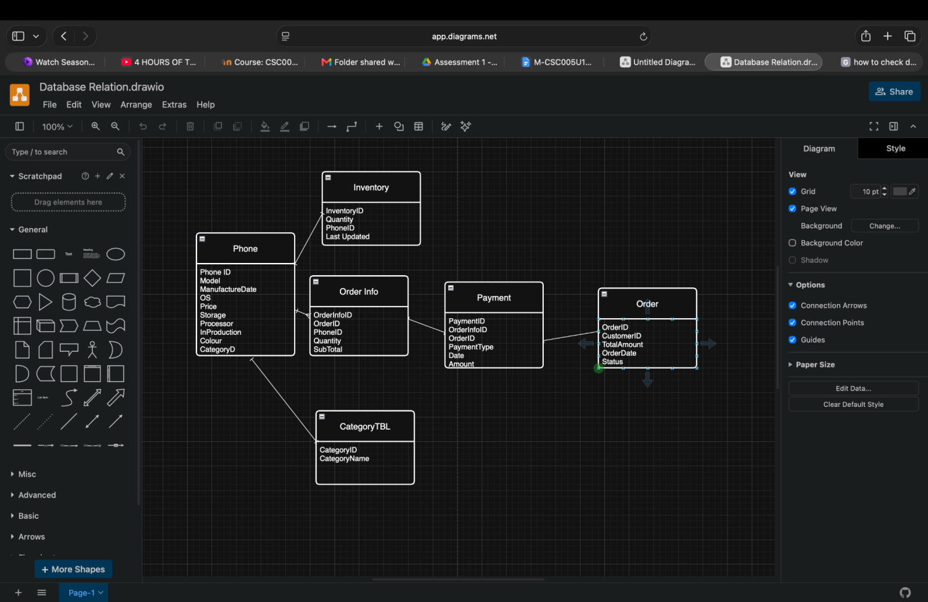
Figure 2 — Relationships between tables

The database tables are linked using one-to-one and one-to-many relationships to maintain data integrity. CategoryTBLhas a one-to-many relationship with Phone, as one category can contain multiple phones. Phone has a one-to-one relationship with Inventory, where each phone has one inventory record, and a one-to-many relationship with Order Info, as a phone can appear in multiple orders. The Order table has a one-to-many relationship with Order Info, allowing one order to contain multiple phone items. The Payment table is linked to Order and Order Info to record payment details for each order. Additionally, the Order table contains a CustomerID, indicating that one customer can place many orders, while each order belongs to one customer.
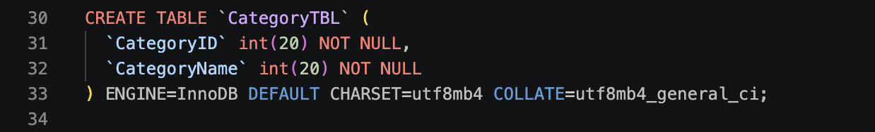
Figure 3 — Creating Tabes
- This code creates a table called CategoryTBL with two columns: CategoryID and CategoryName. Both columns are set to store integer values and cannot contain NULL values

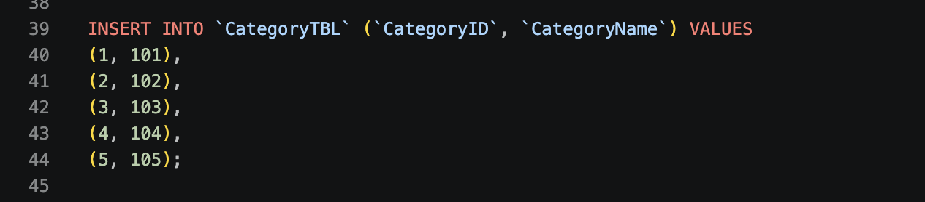
Figure 4 — Inserting into Tabes
This code inserts five records into the CategoryTBL table by assigning values to the CategoryID and CategoryNamecolumns. Each row adds a unique category ID along with its corresponding category number.

Figure 5 — Altering Tabes
This code modifies the existing CategoryTBL table by adding a primary key to the CategoryID column. The primary key ensures that every CategoryID value is unique and cannot be NULL, allowing each record to be uniquely identified.
The database was organised into separate SQL scripts to improve readability, maintenance and future scalability.
The project consisted of the following components:
- Database Creation Script – creates the Voltura Phones database.
- Table Creation Script – defines Customers, Phones, Inventory, Orders, Order_Info and Payment tables.
- Data Insertion Script – populates the database with sample records.
- Query Script – contains SQL statements used for business analysis.
- Python Analysis Script – imports exported CSV files and generates statistical summaries and visualisations.
This modular structure improves code organisation and allows individual components to be modified without affecting the overall database system. All SQL code was documented with comments to improve readability and support future development.

5. Results and Analysis

5.1 Descriptive Statistics
During Analysis exported the dataset to csv then used python to describe the table and create charts to portray different information.

Table 2 presents the descriptive statistics for the key variables in the Order dataset.

Variable | Mean | Std Dev | Min / Max
CustomerID | 13 | 7.359 | 1/25
OrderID | 13 | 7.359 | 1/25
TotalAmount | 395 | 110.397 | 215/575

Table 1 — Descriptive Statistics for Key Dataset Variables

5.2 Visual Outputs

Figure 6 — Distribution of Order status
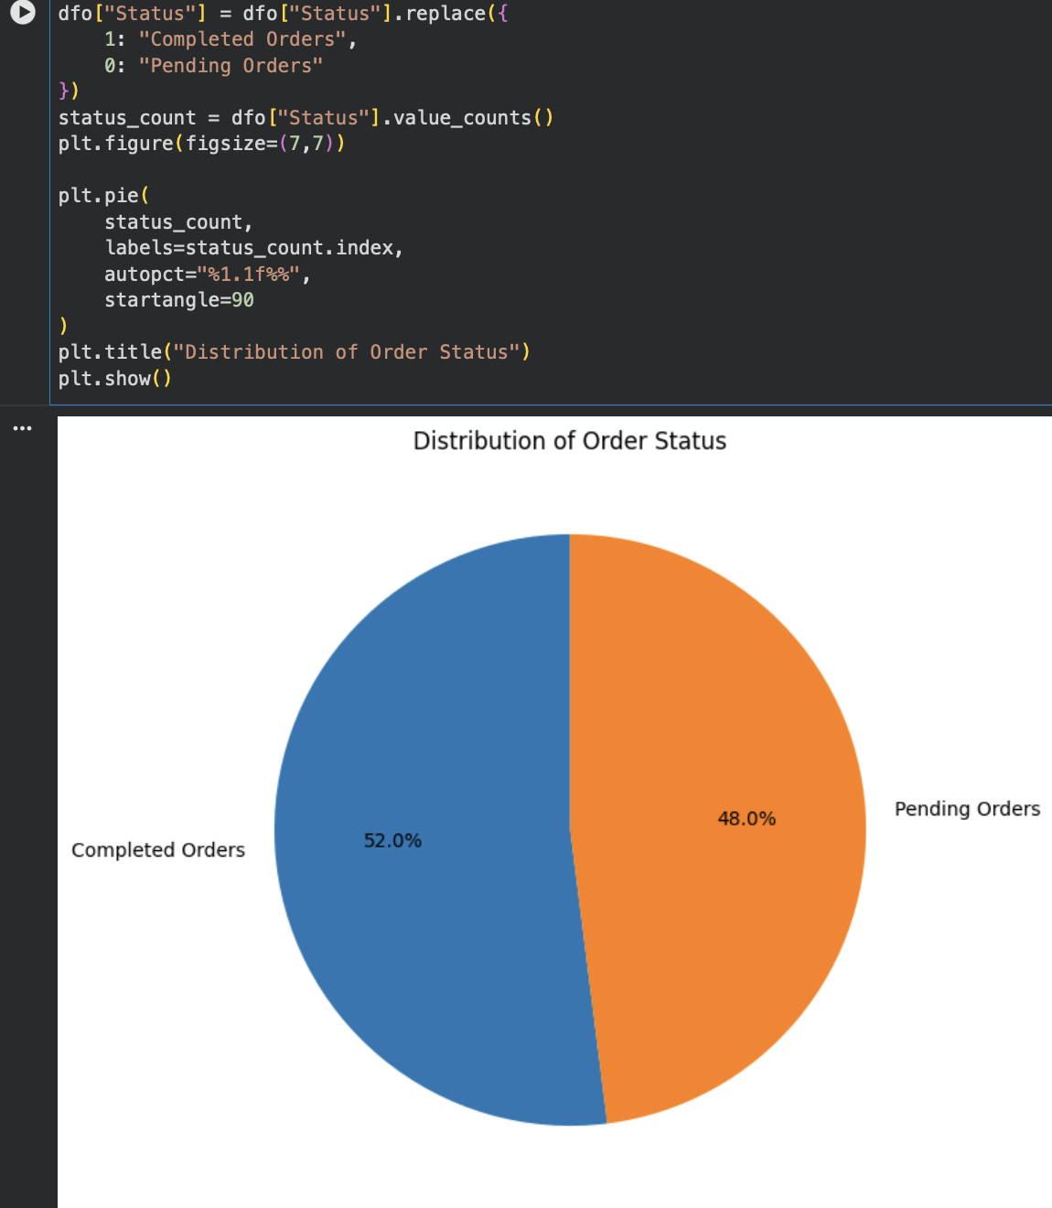

Figure 1 shows The pie chart gives a clear overview of the ratio between different order statuses.
The results indicate that nearly half of all orders remain incomplete. Although completed orders slightly exceed pending or cancelled orders, the proportion of unsuccessful transactions is relatively high. In a commercial environment, this could negatively affect revenue generation and customer satisfaction. Further investigation into order processing procedures, payment systems and inventory availability would help identify the factors contributing to incomplete orders.
Purpose: Shows the proportion of completed and pending/cancelled orders.
Categories: Status
Status 1: 13 orders (52%)
Status 0: 12 orders (48%)
Figure 7 — Order value over time

Figure 2 illustrates This chart helps identify trends in customer spending over time, such as increases or decreases in order values.
Shows how the total amount of orders changes over different dates.
- X-axis: OrderDate
- Y-axis: TotalAmount

Figure 8 — Customer spending pattern
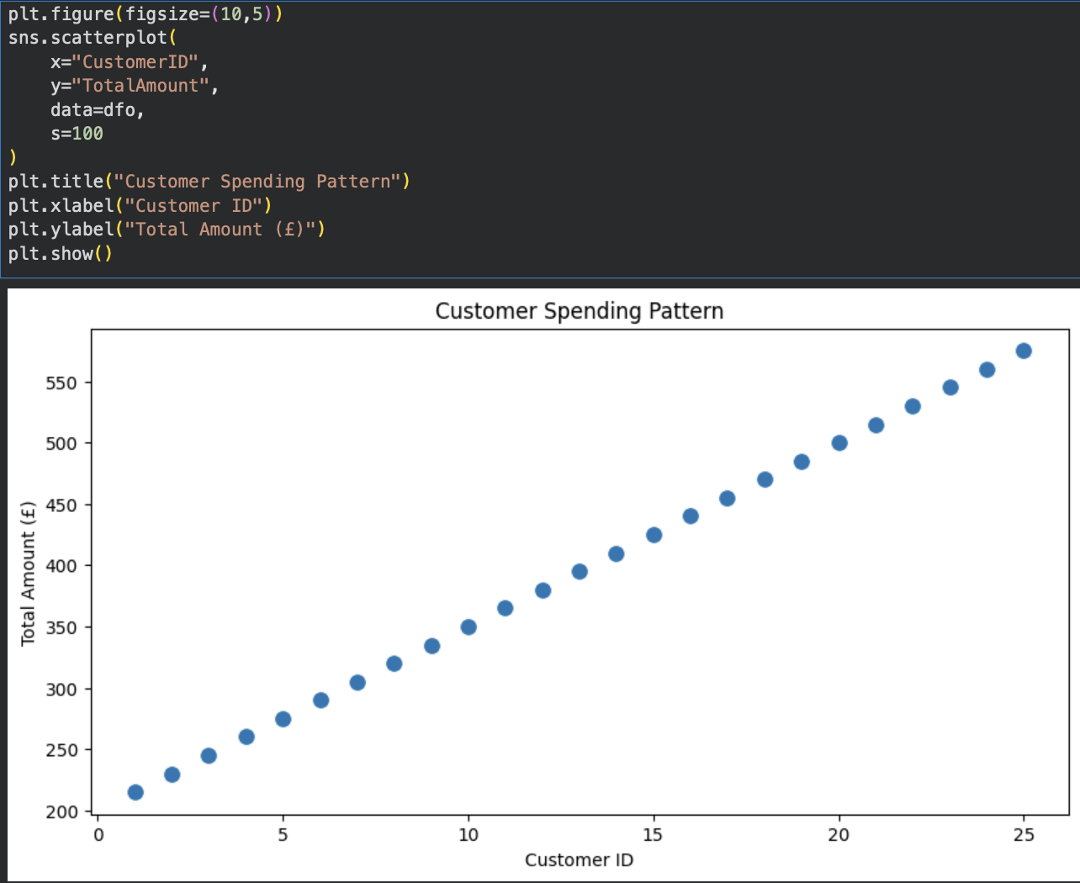
Figure 3 demonstrates This helps identify whether certain customers place higher-value orders and highlights spending patterns.
The customer spending analysis suggests that revenue generation is not evenly distributed among customers. A small number of customers appear to contribute a larger proportion of total sales. This finding highlights the importance of customer retention strategies, loyalty programmes and personalised marketing campaigns aimed at maintaining relationships with high-value customers.
Examines the relationship between customers and their spending.
- X-axis: CustomerID
- Y-axis: TotalAmount
Figure 9 — Distribution of Order Amount
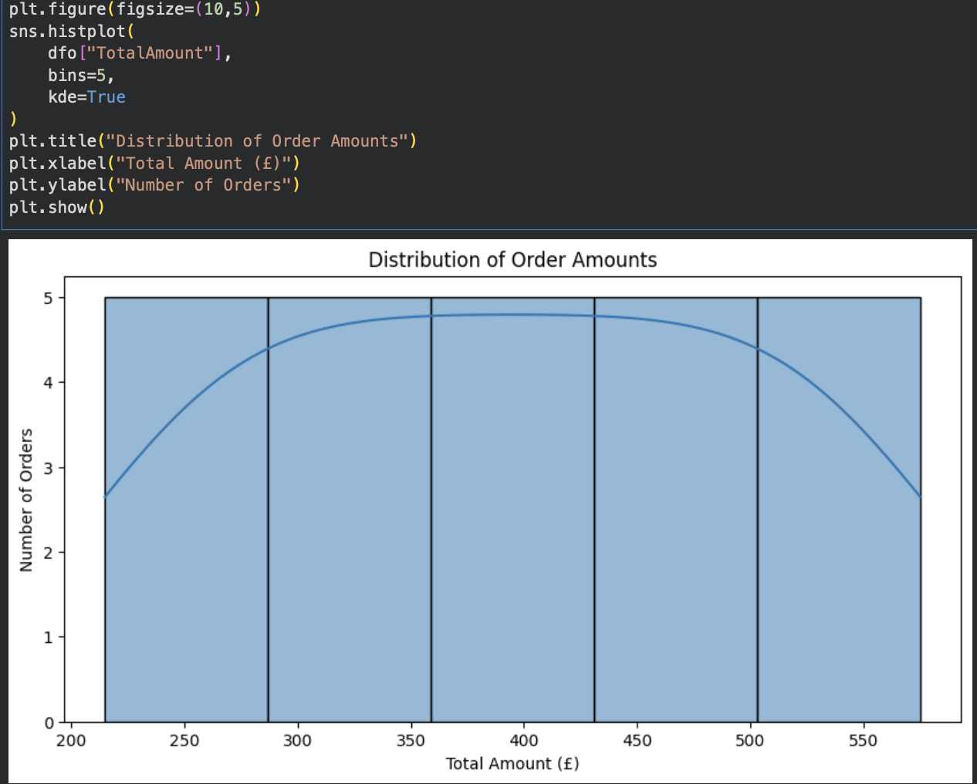
Figure 4 reveals This reveals the most common spending ranges and whether orders are generally low, medium, or high value.
Shows how order values are spread across different price ranges.
- X-axis: TotalAmount ranges
- Y-axis: Number of Orders

5.3 Model Results and Interpretation
The analysis revealed several important trends within the Voltura Phones dataset. The average order value of approximately £395 suggests that customers generally purchase mid-range to premium smartphones. This indicates that the company operates within a competitive market segment where customer purchasing decisions are influenced by product features, pricing and perceived value.
Analysis of order status data showed that 52% of orders were successfully completed while 48% remained pending or cancelled. Although completed orders represent the majority, the proportion of incomplete orders is relatively high. In a real-world environment, this could indicate issues such as payment failures, stock shortages or customer dissatisfaction. Further investigation would be required to identify the root causes and improve conversion rates.
Customer spending analysis demonstrated that some customers contributed significantly more revenue than others. This finding highlights the potential value of customer loyalty programmes and targeted marketing strategies. By identifying high-value customers, the company can focus resources on customer retention and maximise long-term profitability.
The sales trend analysis also revealed fluctuations in revenue over time. Such patterns may reflect seasonal demand, promotional activities or changes in customer preferences. Understanding these trends allows management to make informed decisions regarding inventory planning, marketing campaigns and resource allocation.
Overall, the results demonstrate how structured business data can be transformed into meaningful insights that support operational and strategic decision-making.

5.4 Comparison and Evaluation
The effectiveness of the Voltura Phones database was evaluated by comparing it with traditional spreadsheet-based data management methods. While spreadsheets are suitable for small-scale record keeping, they become increasingly difficult to manage as data volumes grow. Common issues include duplicated records, inconsistent formatting and increased risk of human error.
The relational database addresses these limitations through the use of primary keys, foreign key relationships and structured data validation. These features improve data accuracy, reduce redundancy and ensure consistency across multiple business processes.
From an analytical perspective, SQL provides significant advantages over manual calculations. Aggregate functions such as SUM(), AVG(), COUNT() and GROUP BY enable large volumes of data to be processed quickly and accurately. This allows business managers to generate reports and identify trends more efficiently than would be possible using manual methods.
However, the system also has limitations. The current implementation uses a relatively small synthetic dataset and does not include advanced analytical capabilities such as machine learning, predictive modelling or automated business intelligence dashboards. As a result, the insights generated are primarily descriptive rather than predictive.
Despite these limitations, the database successfully meets the project objectives and provides a scalable foundation for future business growth and more advanced analytical applications.

6. Ethical Considerations

6.1 Data Ethics and Privacy
Although the Voltura Phones database uses fictional customer information, a real-world implementation would contain sensitive personal data including names, addresses, phone numbers and payment details.
To protect customer privacy, organisations should comply with UK GDPR regulations by implementing encryption, access controls and secure authentication procedures. Data should only be collected for legitimate business purposes and retained for the minimum period necessary.
The use of synthetic data in this project eliminated privacy risks while still allowing realistic database design and analysis.

6.2 AI Tool Use
AI tools such as ChatGPT were used to assist with debugging SQL queries, improving report structure and clarifying database concepts. All generated suggestions were reviewed, modified and validated by the project team before implementation.
No AI-generated content was submitted without verification. The final database design, SQL code and analytical results were independently developed and tested by the group.

6.3 Broader Ethical Implications
If deployed commercially, the database would be responsible for storing and processing large amounts of customer information. Security breaches could expose sensitive data and damage customer trust.
Organisations must therefore implement strong cybersecurity measures including encryption, role-based access control and regular security audits. Ethical business practices also require transparency regarding data collection, storage and usage policies.
Maintaining accurate and secure customer records is both a legal and professional responsibility within the computing industry.

7. Conclusions and Recommendations

7.1 Summary of Findings
This project aimed to design and implement a relational database system for Voltura Phones using MySQL and SQL. The database successfully stored and managed customer information, phone products, inventory records, orders and payment transactions.
The analysis showed that the database could efficiently organise large amounts of business data and provide useful insights through SQL queries and visualisations. Descriptive statistics revealed an average order value of approximately £395, while the visualisations highlighted customer spending patterns, order status distributions and sales trends over time. The database demonstrated how structured data can be transformed into meaningful business information to support decision-making.

7.2 Evaluation Against Objectives
Objective 1, to design a relational database, was successfully achieved through the creation of multiple linked tables with primary and foreign key relationships.
Objective 2, to implement the database using SQL, was achieved through the creation of tables, insertion of data and execution of analytical queries.
Objective 3, to store customer, product and transaction data, was achieved through the structured design of the database schema.
Objective 4, to analyse sales and customer trends, was achieved using SQL aggregate functions and statistical analysis.
Objective 5, to create visual representations of the results, was achieved through the development of charts and graphs using Python.
Overall, all project objectives were successfully completed.

7.3 Limitations
The primary limitation of this project is that the dataset was simulated rather than obtained from a real business environment. As a result, customer behaviour and purchasing patterns may not fully reflect real-world conditions.
Another limitation is the relatively small dataset size, which restricts the complexity of statistical analysis that can be performed. Additionally, the database does not currently include advanced features such as automated reporting, customer segmentation or predictive analytics.

7.4 Recommendations and Future Work
Based on the findings, it is recommended that Voltura Phones continues to use relational database technology to manage business operations and support decision-making.
Future improvements could include:
- Expanding the database with larger and more realistic datasets.
- Developing a web-based interface for customer and staff interaction.
- Implementing automated dashboards for real-time sales reporting.
- Adding predictive analytics to forecast sales trends and customer demand.
- integrating advanced security measures such as data encryption and role-based access control.
These improvements would increase the functionality, scalability and business value of the database system.

8. References
VanderPlas, J. (2016) Python Data Science Handbook. Sebastopol: O'Reilly Media. Available at: https://jakevdp.github.io/PythonDataScienceHandbook/ (Accessed: 1 June 2026).
Connolly, T. and Begg, C. (2015) Database Systems: A Practical Approach to Design, Implementation and Management. 6th edn. Harlow: Pearson.
Date, C.J. (2019) An Introduction to Database Systems. 8th edn. Harlow: Pearson Education.
Elmasri, R. and Navathe, S.B. (2017) Fundamentals of Database Systems. 7th edn. Boston: Pearson.
Hunter, J.D. (2007) ‘Matplotlib: A 2D Graphics Environment’, Computing in Science & Engineering, 9(3), pp. 90–95.
McKinney, W. (2022) Python for Data Analysis: Data Wrangling with Pandas, NumPy and Jupyter. 3rd edn. Sebastopol, CA: O’Reilly Media.
MySQL (2026) MySQL 8.0 Reference Manual. Available at: https://dev.mysql.com/doc/ (Accessed: 24 June 2026).
Pandas Development Team (2026) Pandas Documentation. Available at: https://pandas.pydata.org/docs/ (Accessed: 24 June 2026).
phpMyAdmin Development Team (2026) phpMyAdmin Documentation. Available at: https://docs.phpmyadmin.net/ (Accessed: 24 June 2026).
Python Software Foundation (2026) Python 3 Documentation. Available at: https://docs.python.org/3/ (Accessed: 24 June 2026).
Silberschatz, A., Korth, H.F. and Sudarshan, S. (2019) Database System Concepts. 7th edn. New York: McGraw-Hill Education.

Appendix A — Group Contribution Summary
Name | Student ID | Contributions | Est. %
David Anyanwu | 25016843 | Section 1-7, Visualization, Data cleaning, Populating tables | 95%
Rayamajhi Bardan | 25016803 | Created some database design and tables | 5%

Table 2 — Group Member Contribution Summary

Appendix B — Individual Reflective Statement

B.1 Reflective Statement — [David Anyanwu, 25016843]
Following the departure of my former group member, I completed the Voltura Phones project independently with guidance and academic support from my lecturer, Mr Kenneth Nweke. Although the project was originally intended to be completed as part of a group, taking responsibility for the entire project became a valuable learning experience that allowed me to develop both my technical and organisational skills.
My primary contribution was the design and implementation of the Voltura Phones relational database. I created the database structure, designed the tables, established primary and foreign key relationships, and ensured that the database followed good relational database design principles. I also populated the database with realistic sample data representing customers, phones, inventory records, orders and payments. In addition, I developed and tested SQL queries that were used to analyse customer spending behaviour, sales trends and order information.
One of the most challenging aspects of the project was ensuring that all tables were correctly linked and that the relationships between them maintained data integrity. During development, I encountered issues with foreign key constraints and query results that did not initially return the expected output. To overcome these challenges, I carefully reviewed my database design, tested queries individually and consulted documentation and learning resources to improve my understanding of SQL relationships and joins. This process improved my problem-solving skills and taught me the importance of systematic testing when developing database systems.
Another challenge was completing the entire project independently after my group member left. Managing the database implementation, data analysis, visualisations and report writing required effective time management and self-discipline. I created a structured plan to divide the workload into manageable tasks and monitored my progress regularly. This helped me meet project requirements despite the additional responsibilities.
The mathematical and analytical concepts that I found most valuable were descriptive statistics and data analysis techniques. By calculating measures such as averages and analysing trends within the dataset, I gained a better understanding of how raw data can be transformed into meaningful business information. I also learned how SQL aggregate functions such as COUNT(), SUM() and AVG() can be used to extract useful insights from large datasets efficiently. Using Python to generate charts and visualisations further strengthened my ability to interpret and communicate analytical findings.
Although the project was ultimately completed independently, I still benefited from academic guidance and feedback throughout the development process. Discussions with my lecturer helped me improve the quality of my database design and encouraged me to think critically about the relationship between data management and business decision-making. This support contributed significantly to my learning and confidence in database development.
Overall, this project has strengthened my knowledge of SQL, relational database design, data analytics and technical report writing. It has also improved my confidence in working independently and solving technical problems. In future projects, I would like to further develop my skills in advanced SQL techniques, database optimisation and predictive analytics. These areas would enable me to build more sophisticated data-driven solutions and continue developing as a computing professional.

Github Repository link: https://github.com/daveany/Phone-company.git
Phpmyadmin link: http://217.76.58.188/phpmyadmin/
DB Name: Voltura Phones
Username: David
Password: Password1234$

